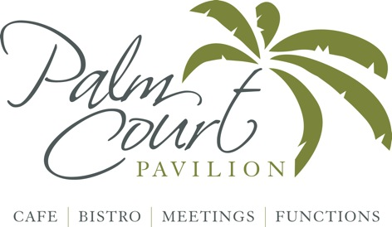

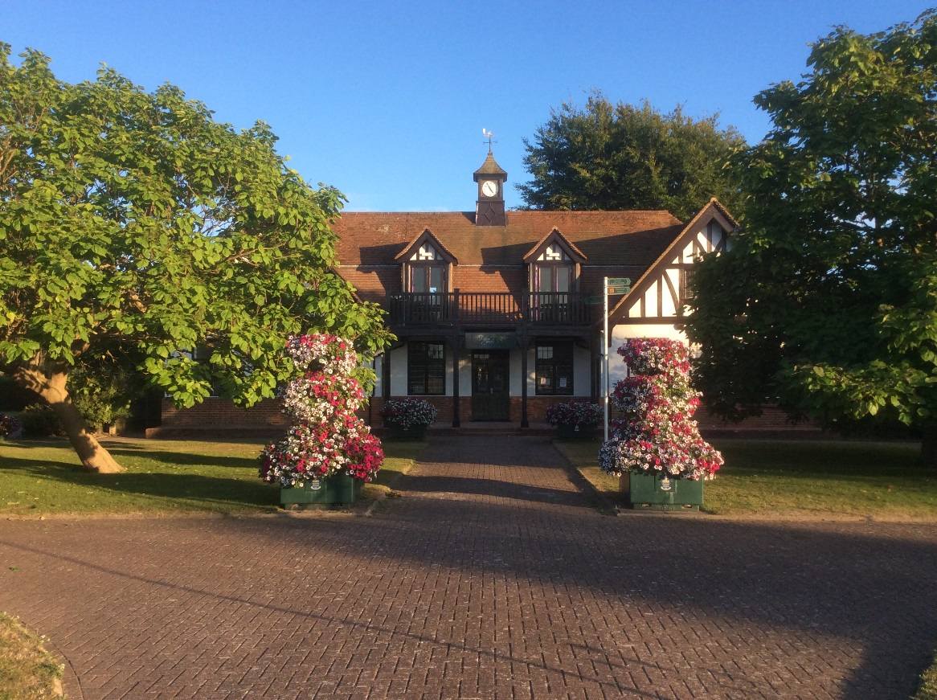

**Function Information & Menus**



**About us**

Nestled in Worthing’s stunning Beach House Park: Palm Court Pavilion is a stylish,

beautifully renovated café-bistro in the park’s Old Pavilion. Located just minutes from

the town centre and the seafront, Palm Court Pavilion serves delicious homemade food

and has a range of options for functions and events.

The cafe is an exciting new chapter in the Pavilion’s interesting history; after some years

in disuse, the Pavilion has been given a new lease of life. The landmark building has been

sympathetically renovated, emphasising the natural light and an extensive outdoor decking

area makes the most of the beautiful park setting. Both areas of decking can be used for

private parties.

The upstairs function room has a balcony giving delightful views of the park and bowling

greens, a perfect venue for parties, meetings and events.

The outside space in the park can also be used for larger scale events of up to 1000 people,

ideal for weddings, dining, exhibitions, corporate launches, markets and roadshows.

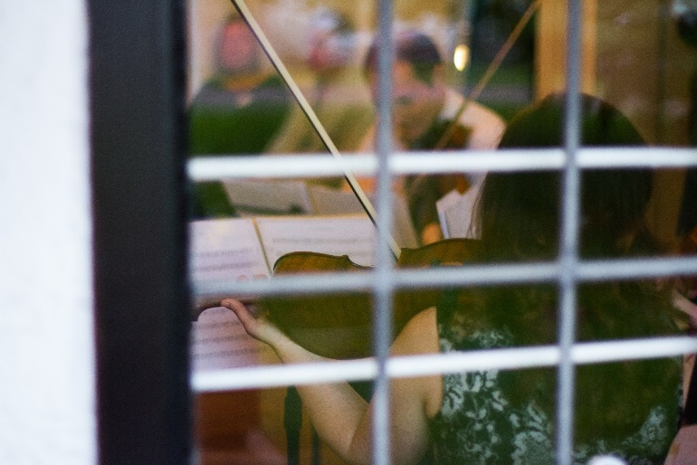

**Room Capacity & Rates**

|  |  |  |  |  |  |
| --- | --- | --- | --- | --- | --- |
| **Room** | **Park View Room** | **Palm Court** | **Beech Terrace** | **Maple Terrace** | **External Marquee** |
| Full Day  9am- 6pm | £100 - £175 | On Request* | | | |
| Evening  7pm-10pm | £50 - £100 |
| **Maximum Capacity** |  | | | | |
| Board Room | 36 | n/a | n/a | n/a | On request |
| Theatre | 60 | n/a | n/a | n/a | On request |
| Dining | 40 | 70 | 75 | 90 | 75 - 1000 |
| Buffet | 60 | 90 | 120 | 150 | On request |

* Prices depend on numbers & menu chosen

** Park View room has a ceiling mounted HDMI Projector

**Parking**

Ample parking available (pay & display every day 8am – 6pm)

Free after 6pm

**Park View Room**

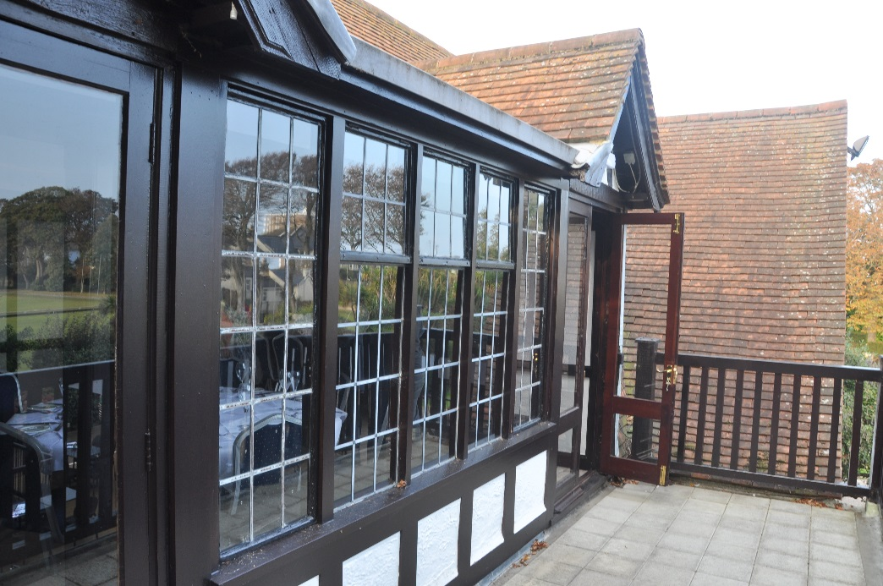

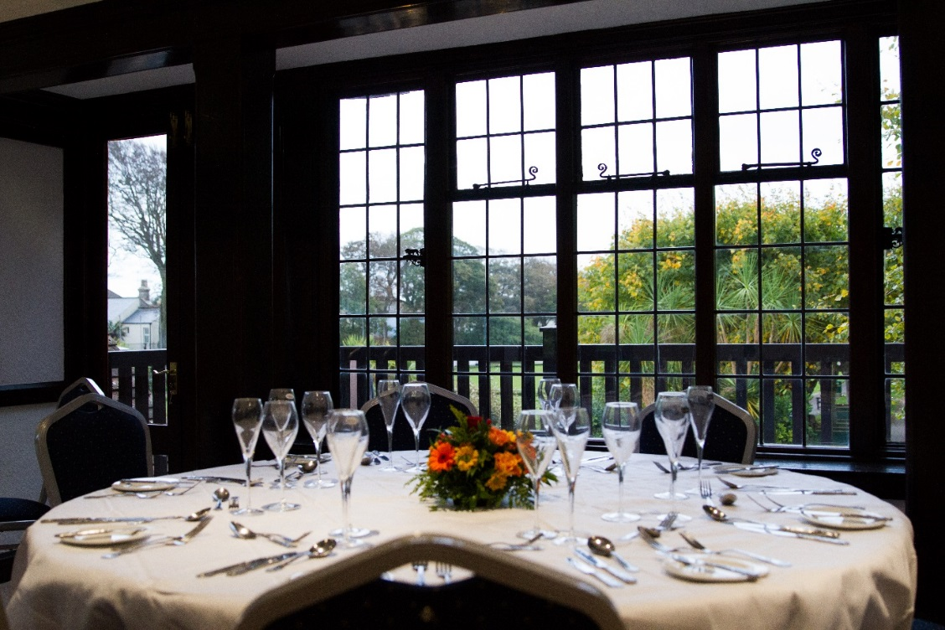

**Maple Terrace  
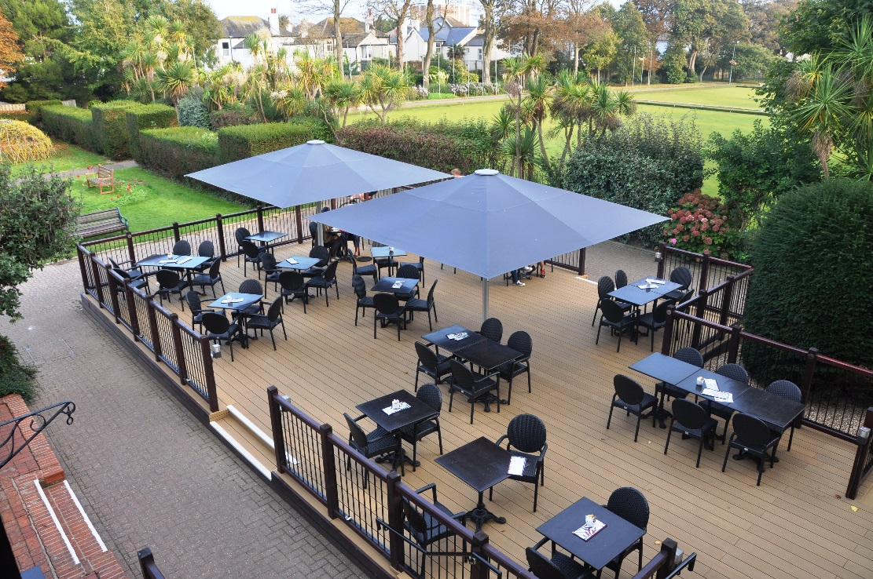**

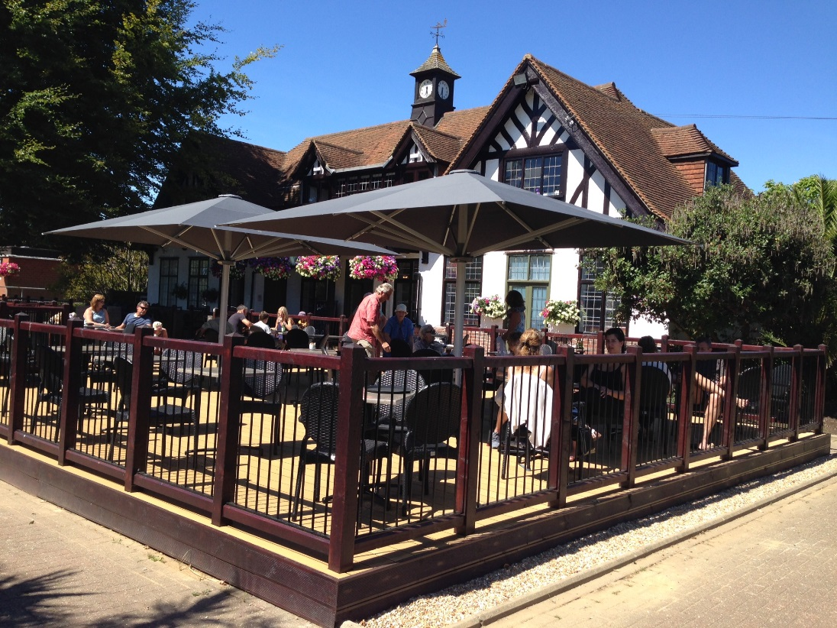**Beech Terrace**

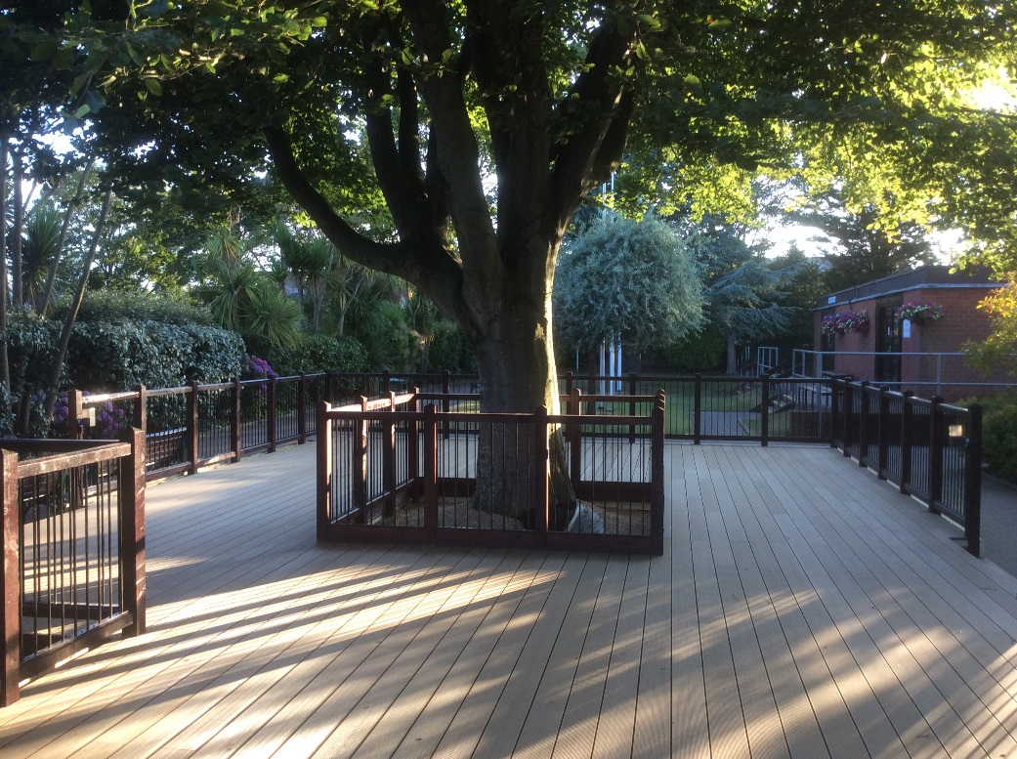

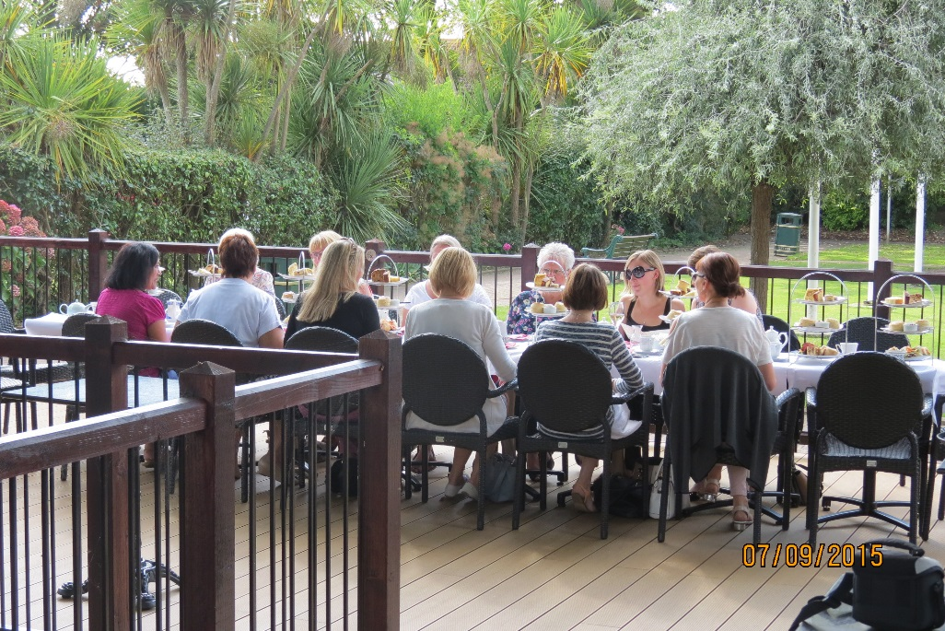

**External Marquee**

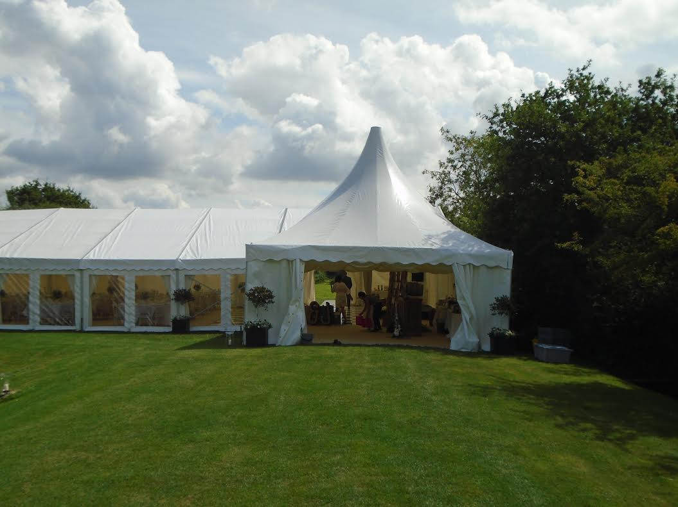

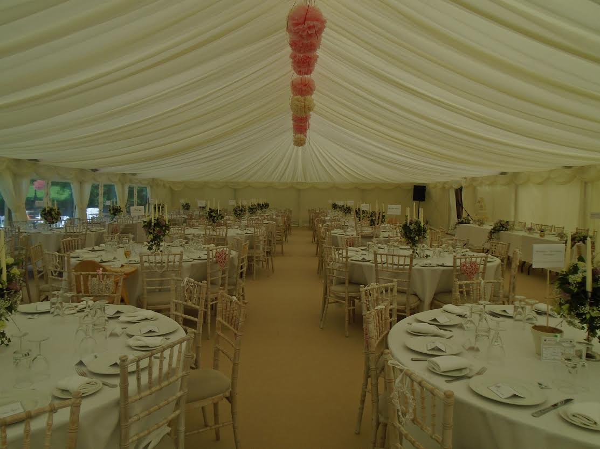

**Banqueting Menu**

**2 Courses from £27.50**

**3 Courses from £33.95**

**Starters**

Smoked salmon with dill & caper dressing served with bread & butter

Chicken liver pate with apricot chutney served with sourdough bread

Tomato & mozzarella with a pesto dressing

Homemade soup of the day served with sourdough bread

**Main courses**

Chicken breast wrapped in Parma ham & stuffed with cheese & sun blush tomatoes

Salmon fillet poached in lemon, herb & white wine sauce

Slow roast pork belly in a cider cream sauce

Seasonal vegetable dish in puff pastry

*All main courses served with Chef’s choice of potato & vegetables*

**Desserts**

Lemon tart with raspberries

Sherry trifle cups

Trio of chocolate desserts – a mousse, a tart & a caramel brownie

Cheese Board (supplement £2.00)

Tea & coffee £1.25

**Canape Menu**

**Cold Canapés**

Smoked salmon & horseradish cream

Pear, stilton & walnut

Coronation chicken

Watermelon & feta skewers

**Hot Canapés**

Lime & chilli chicken

Sweet potato frittata

Tomato & feta tartlet

**Dessert Canapés**

Mini scones with clotted cream & jam

Strawberries dipped in chocolate

Mini Bakewell tart

Chocolate mousse served in an espresso cup

Mini Cranachan - Raspberry coulis, cream & oats

Chocolate brownie wrapped in pineapple mint leaves

**£7.50 per person (5 items) £9.95 per person (7 items)**

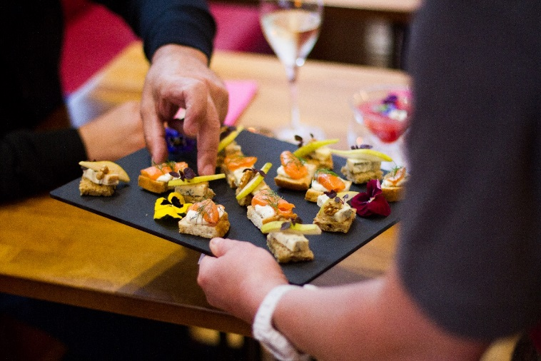

**Buffet Menu**

Build a fabulous colourful display to suit your tastes and requirements.

Some popular suggestions are:

**Finger foods**

Sandwiches on a variety of breads

Larger versions of our canape style menu

Individual seasonal tartlets and filo pastry parcels

Chicken and beef satay skewers

Lemon and lime chilli chicken kebabs

Mini samosas

Sliced fruit platter

**Fork Foods**

Salads from our salad list available upon request

Salmon Nicoise with eggs and olives

Chicken Caesar with bacon

Slices of seasonal tartlets, quiches and filo parcels

**Speciality platters**

Whole dressed salmon with prawns

Cold carved meats

Deluxe cheese board

Hot options served in Chafing dishes

Mediterranean Lamb

Seafood pie with luxury cheese topping

Moussaka

Indian and Thai Curries

**Prices from £14.95 per person for a cold finger buffet with 5 items**



**Street Food**

**Barbecue**

Chicken kebabs marinated in lime & ginger

Pork spare ribs in bbq sauce

Mini homemade burgers

Butchers sausages

Prawn skewers marinated in chilli & garlic

Halloumi cheese, pepper & tomato skewers

Mixed vegetable skewers

& Salads

From £20 per person for 4 choices with 2 salads of your choice and baskets of bread,

buns and sauces.

**Pizza**

The dough bases are hand rolled and shaped to approximately ten inch pizza bases or mini individual pizza bases.

Wood fired pizza **£ 9.95** per person

- With salads **£12.00** per person

**Hog Roast** Minimum of 50 people

All our hog roasts arrive racked and ready to be slow cooked on site for five hours. We can serve as a buffet or plated and served to your tables

**£16.00** per person

**Paella**

Rich, colourful, flavoursome and cooked in our huge paella pans in front of your guests, we can offer you meat, seafood and vegetarian options. You can choose ingredients such as chicken, chorizo, prawns, mussels, peppers.

Your choice of Paella

Mixed salad leaves, tomato & fresh basil, sliced cucumber, peppers and onion

**£14.00** per person



**Delegate Menu**

**Cost per head**

**Breakfast**

Continental Buffet **£6.95**

* Cold meats, cheeses, pastries & rolls
* Fruit juice, tea & filter coffee

**Lunch Option A £4.95**

Mixed sandwich platter

Fruit platter

**Lunch Option B £6.95**

Mixed sandwich Platter

Warm quiche of the day

Selection of salads

**Lunch Option C £7.95**

Hot dish of the day with accompaniments

Vegetarian dish of the day available

**All menus for a minimum of 10 delegates**

**Terms & Conditions**

|  |  |
| --- | --- |
| **VAT** | All prices shown are inclusive of VAT |
| **Free consultation** | Our Head Chef Sam would be happy to meet you, discuss your plans and work with you and your budget to create a bespoke menu |
| **Tasting session** | We are pleased to offer you a tasting session for a fee of £40.00 which is refunded if you book with us |
| **Crockery and Glassware deposit** | For outdoor events a deposit of **£200** will be required to cover any broken or missing china or glass ware. The deposit will be refunded after the event either in full or to cover broken or missing items. |
| **Booking and confirmation** | If you wish to proceed with the booking, we will issue an invoice for a non-refundable 25% of the agreed total. **The booking is not confirmed until the 25% deposit has been received**. The remaining balance is due 14 days prior to the event date. |





